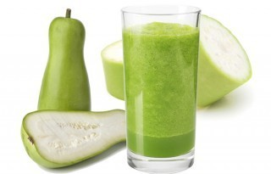

* Bottle gourd is around 92% water
* It is one of the healthiest vegetables around
* Among other things, it helps lower bad cholesterol levels too
* Bottle gourd juice has a cooling effect on your body and keeps your body hydrated especially during summers. It keeps your stomach cool and reduces [body heat](https://food.ndtv.com/health/water-your-best-drink-to-fight-the-heat-693021).
* Bottle gourd juice is widely used for weight loss. It is packed with fiber which helps in keeping you full for longer and it is also low in calories
* It also contains essential vitamins and minerals like Vitamin C Vitamin B, Vitamin K, Vitamin A, Vitamin E, Iron, Folate, Potassium and Manganese
* Drinking freshly squeezed bottle gourd juice mixed with some[lime juice](https://food.ndtv.com/ingredient/lemon-juice-701105) is one of the bets natural remedies to treat urinary tract infections.
* Bottle gourd juice helps in curing [constipation](https://food.ndtv.com/health/6-effective-home-remedies-for-constipation-1216545) and also treats diarrhoea
* According to Ayurveda, bottle gourd juice is great for [digestion](https://food.ndtv.com/health/eating-kiwi-improves-digestion-693892).
* Regular consumption of bottle gourd juice on an empty stomach every morning helps in lowering your blood cholesterol levels and maintains [healthy heart](https://food.ndtv.com/health/world-heart-day-2015-what-to-eat-avoid-1224178) functions
* Bottle gourd contains a good amount of choline – a kind of neurotransmitter that helps in improving the functions of the brain and helps in preventing [stress](https://food.ndtv.com/opinions/stress-can-lead-to-overeating-health-experts-695648), [depression](https://food.ndtv.com/health/lack-of-sleep-may-put-your-child-at-depression-risk-1435788) and other mental disorders
* Bottle gourd juice acts as a natural [post workout](https://food.ndtv.com/health/what-to-eat-after-the-gym-5-points-to-lose-weight-the-healthy-way-1414713) drink